Office Expenses (main menu)
Add Expense (sub menu)
View Expenses (sub menu)
Filter Option (sub menu)

Add Expense (sub menu)

Auto created date input: This one will be record purpose (only for database) please keep this hidden
Auto created user information: This one will be record purpose (only for database) please keep this hidden

Date: User will input this
Title: User will input this
Categories: There should be a drop-down menu and must be an option where managers can create the categories. Currently we have those categories.
- Stationary
- Appliance
- Computer Accessories
- Grocery
- Repairing Cost
- Internet Bill
- Office Rent
- Electricity Bill
- GAS bill
- Oil bill
- Taxi Bill
- Charity
- Mobile allowance
- Mobile Top-up
- Transport
- Gift
- Conference Cost
- Rob BD expense
Quantity: user will put this
Total Price: user will put this
Unit price: Automatic (total/quantity)
Comment: user will put this (optional)
Invoice: multi file upload – delete/view/download
Import: Impot from file (only managers can import the previous excel file)
Submit: when user press submit button then this on will be recorded and all filed will be cleared for new entry.

View Expense: (Sub menu)
Date:
Title:
Category:
Unit Price:
Total Price:
Comment:
Invoice:
Edit: user can edit the any field (only manager can edit)
Delete: use can delete the entry (only manager can delete)
View: only invoice will show

You can follow this structure
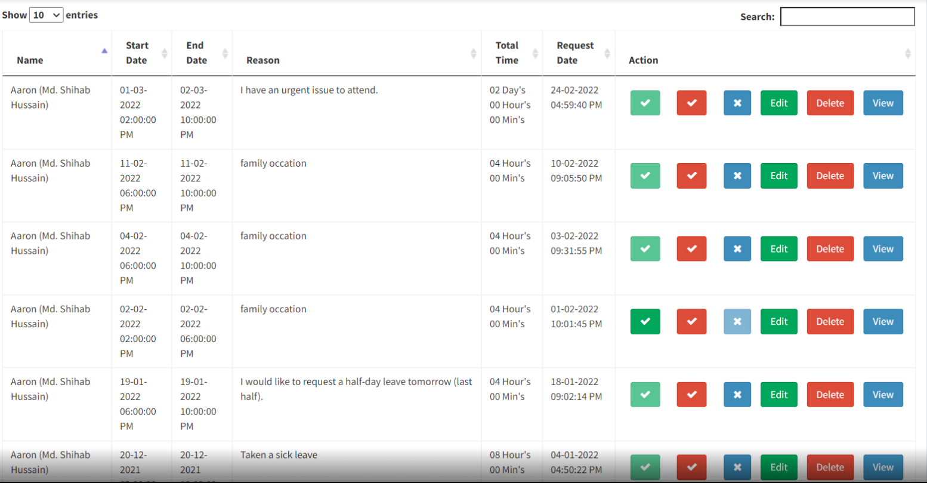

Filter Option (sub menu)
Category:
Start Date:
End Date:
Filter/View: There will be two filters date and categories. If we don’t select any then all should be selected by default.
Export: user can export the excel file by clicking export button.

